**EMBEDDED SYSTEM AND DESIGN**

**EXPERIMENT NO. 6**

**Automatic Trash Can**

Name: NAVARRO, ROD GERYK C.

Course/Section: CPE160P-4/A1

Group No.:

Date of Performance: 09/16/2024

Date of Submission: 09/23/2024

CYREL O. MANLISES, PH.D.

Instructor

**DISCUSSION**

In the experiment the first thing that I did is to create the circuit with the use of two servo motors, one ultrasonic sensor, and the Arduino kit. I have decided to use two servo motors instead of one stepper motor and one servo motor because in this experiment I needed a motor arm that can control the cover and the compressor of the trash can. Since my servo motors are the only one that has an arm, and the available stepper motor in the kit does not have any arm, I decided to use my two servo motors. I also used an ultrasonic sensor for the detection of the trash inside the trash can if it reaches the threshold. I designed the trash can were the opening is in the front, and its cover is placed on the top in order to show clearly how the mechanism works. For the compressor I have used a rotational mechanism made from a tune winder of my guitar which I have experimented to push down a cardboard to compress the trash. The servo motor will rotate to a certain angle to forced the rotational mechanism to push down the cardboard to compress the trash inside if the trash reached the threshold.

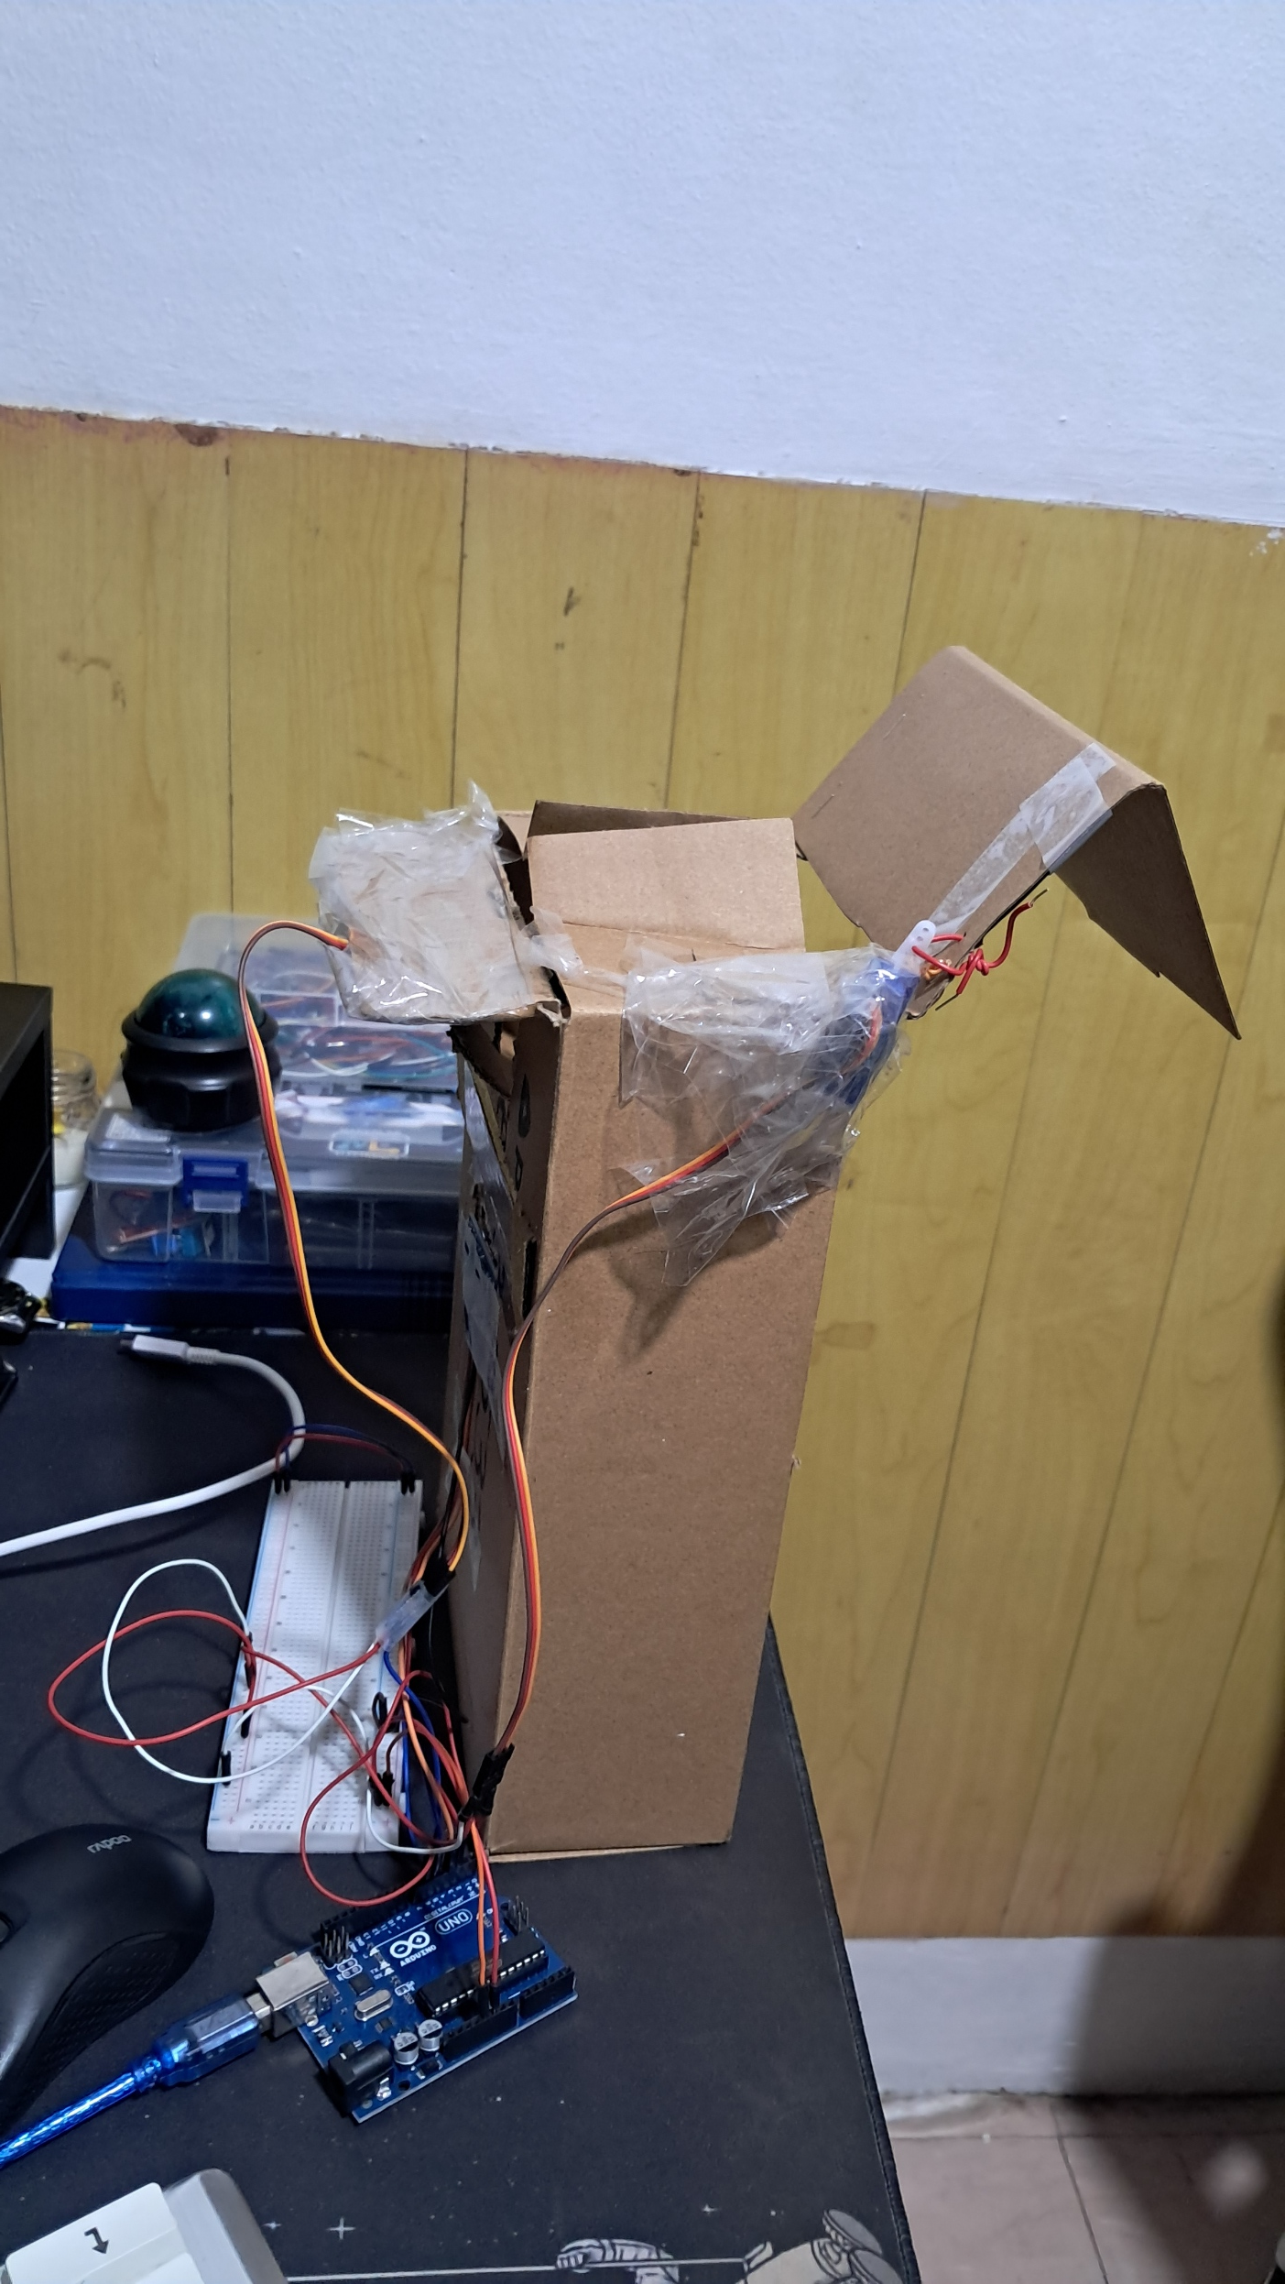

**Figure 1:** The side of the trash can and a circuit that has an ultrasonic sensor and two servo motor connected to the Arduino board,

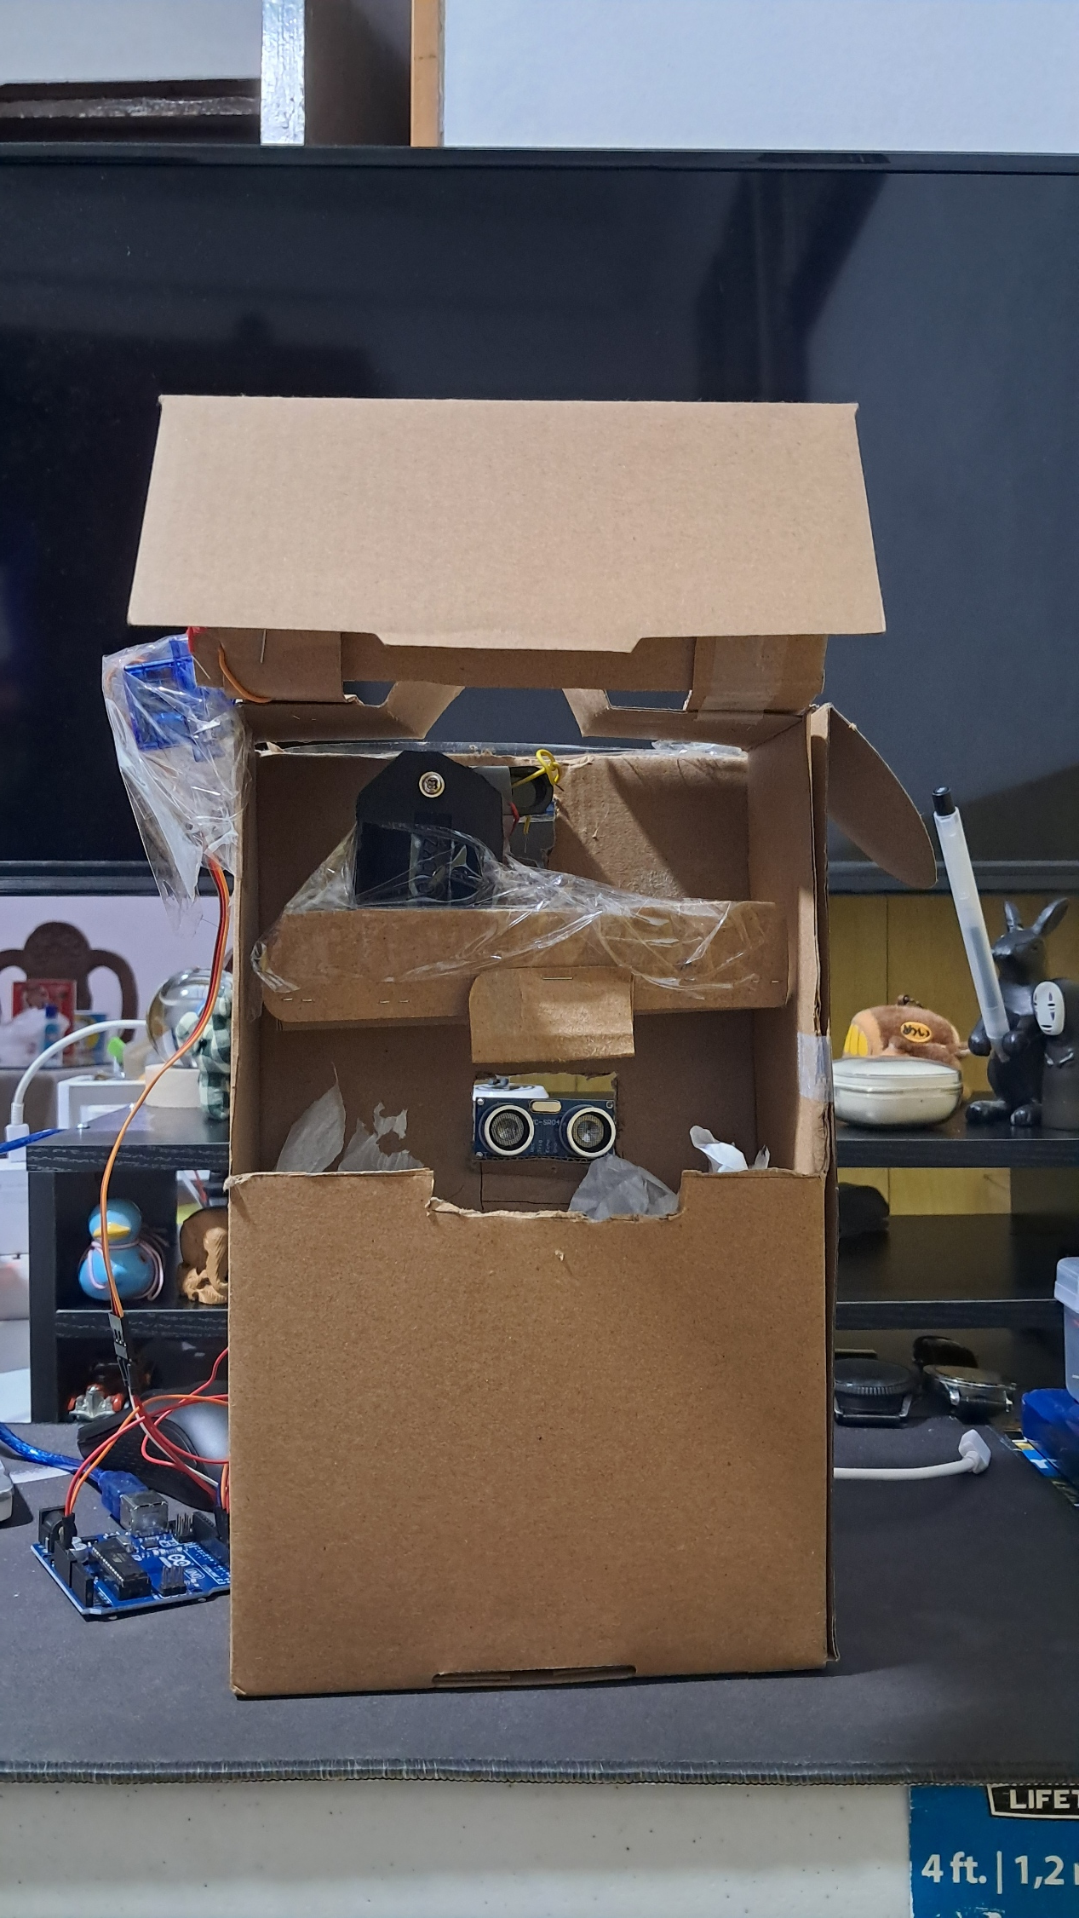

**Figure 2:** The front of the trash can, showing the rotational mechanism of the compressor and the opening,

After creating the circuit, I began to design the trash can as shown in figure 1 and 2. The main goal of this experiment is to imitate how a real automatic trash can works. A mechanism inside the trash can powered by a servo motor that will rotate to 90-degree angle to push down the trash inside if reaches the set threshold. Another servo motor is placed outside the trash can that will also rotate to a 90-degree angle to close the cover of the trash can if the trash inside reached the threshold. The trash can cover is open or lifted upward by default, so the whole system works if the trash inside reached the threshold of the trash can which indicates that the trash can is already full, the cover will automatically close, and after it closes the compressor inside will compress the trash downward, after the trash inside have already pushed down by the rotational mechanism the cover will open again to receive more trash or to collect the trash (make sure it is off before removing the trash).

In the next part of the experiment, I began to create the code of the trash can simulation that will control the movement of the compressor and the cover. In the code, if there are no trash detected at the threshold the trash can is open, so the pos = 0, the pos controls the position of the arm of the servo motors. If the trash inside reached the threshold the pos = 120, and it will close the cover and will began to compress the trash. After the compression it will open again to receive more trash. The trash will be detected at the range of 10 cm. So, if there is trash is detected at the set sensing range the process of the compression and the movement of the cover will start.

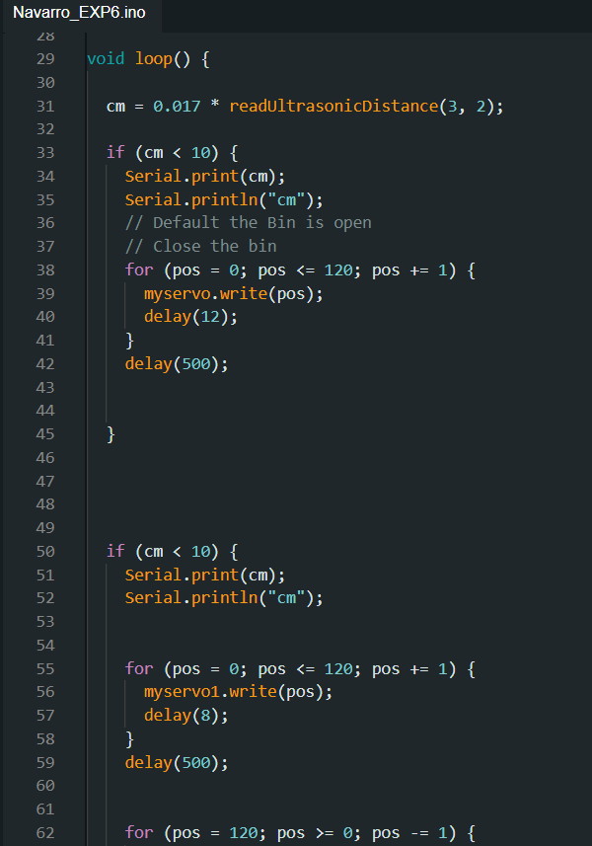

**Figure 3:** The code that simulates the automatic trash can.

**CONCLUSION**

In this experiment, the goal was to build a simple automatic trash can using two servo motors, an ultrasonic sensor, and an Arduino kit. The ultrasonic sensor detects when the trash reaches a certain level (the threshold), triggering the movement of the servo motors. One motor controls the cover of the trash can, which closes when the trash is full, while the other motor operates a compressor mechanism to compact the trash. I chose to use two servo motors instead of a stepper motor because they had the necessary arms to control both the cover and the compressor effectively.

Once the circuit was built, I designed the trash can and wrote a code that allowed the system to work automatically. The cover stays open by default, but when the trash reaches the 10 cm threshold, the cover closes, and the compressor pushes the trash down. After the compression is complete, the cover reopens, ready to receive more trash. This setup effectively simulates how a real automatic trash can operates by using simple components and a straightforward mechanism.